Course Name: | Elements of Electrical and Electronics Engineering | Semester: | I
Date of Submission: | 31 / 01 / 2022 | Batch No: | A2
Faculty Name: | Maruti Zalte | Roll No: | 16010121045
Faculty Sign & Date: |  | Grade/Marks: | / 20

Internal Assessment: 2
Case study on Electricity consumption and billing of a home
- What is electrical power and energy? What are their units?
Ans: Electric power:
Electric power is the rate at which work is done or energy is transformed in an electrical circuit. Simply put, it is a measure of how much energy is used in a span of time.
The SI unit of power is the watt or one joule per second.
1 Watt (W) = 1 Joule / Second (J/s)
$P = IV = I^{2}R= \frac{V^{2}}{R}$
Where V is Volts, I is Current & R is the Electrical Resistance.

Electric Energy:
Electrical energy is the energy derived from electric potential energy or kinetic energy of the charged particles. In general, it is referred to as the energy that has been converted from electric potential energy. We can define electrical energy as the energy generated by the movement of electrons from one point to another.SI unit of electrical energy is Joule.
1 Joule = 1 Volt x 1 Ampere x 1 Second

- What is 1-unit electrical energy?
Ans: Unit Electricity is the amount of electrical energy consumed by a load of 1 kW power rating in 1 hour. It is basically measurement unit of electrical energy consumption in Joule.
1 Unit Electricity = 1 kWh
= 1 kW x 1 Hour = 1000 W x 3600 seconds = 3.6×106 Joule

- Estimate The Electricity Consumption of Your Home For 2 Months (Units/Month) December & January. (Following Table Is Applicable as Usual)

For December 2021: -
Sr. No. | Appliances | Power Rating (watts/appliance) (a) | No of appliances  (b) | Utilization in Hours per day  (c) | Energy in Wh/1000 (units)/day  (d=axbxc)/1000 | Energy units/month  dx30
1 | Lights | 10  7 | 10  5 | 5  5 | 0.5  0.175 | 15  5.25
2 | Fans | 30 | $$4$$ | 20 | 2.4 | 72
3 | AC | 1000 | 1 | 1 | 1 | 30
4 | Washing Machine | 1000 | 1 | 1 | 1 | 30
5 | Electric water heaters (Geysers ) | 500 | 1 | 1 | 1 | 15
6 | Monitor | 25 | 1 | 4 | 0.1 | 3.0
7 | Phones | 10 | 4 | 5 | 0.2 | 6.0
8 | Television | 100 | 1 | 2 | 0.2 | 6.0
9 | Refrigerator | 180 | 1 | 24 | 4.8 | 129.6
10 | Laptop | 30 | 1 | 5 | 0.15 | 4.5
Total energy (Units/month) |  |  |  |  |  | 316.35

For January 2022: -
Sr. No. | Appliances | Power Rating (watts/appliance) (a) | No of appliances  (b) | Utilization in Hours per day  (c) | Energy in Wh/1000 (units)/day  (d=axbxc)/1000 | Energy units/month  dx30
1 | Lights | 10  7 | 10  5 | 6  6 | 0.6  0.21 | 18  6.3
2 | Fans | 30 | $$4$$ | 15 | 1.8 | 54
3 | AC | 1000 | 1 | 0 | 0 | 0
4 | Washing Machine | 1000 | 1 | 1 | 1 | 30
5 | Electric water heaters (Geysers ) | 500 | 1 | 2 | 1 | 30
6 | Monitor | 25 | 1 | 5 | 0.125 | 3.75
7 | Phones | 10 | 4 | 6 | 0.24 | 7.2
8 | Television | 100 | 1 | 2 | 0.2 | 6.0
9 | Refrigerator | 180 | 1 | 24 | 4.8 | 129.6
10 | Laptop | 30 | 1 | 5 | 0.15 | 4.5
Total energy (Units/month) |  |  |  |  |  | 289.35

Plot a bar Graph showing appliances on x-axis and energy (units/month/appliance) on Y –axis. Draw the graph for both the months (Use can Microsoft Excel to plot graphs)
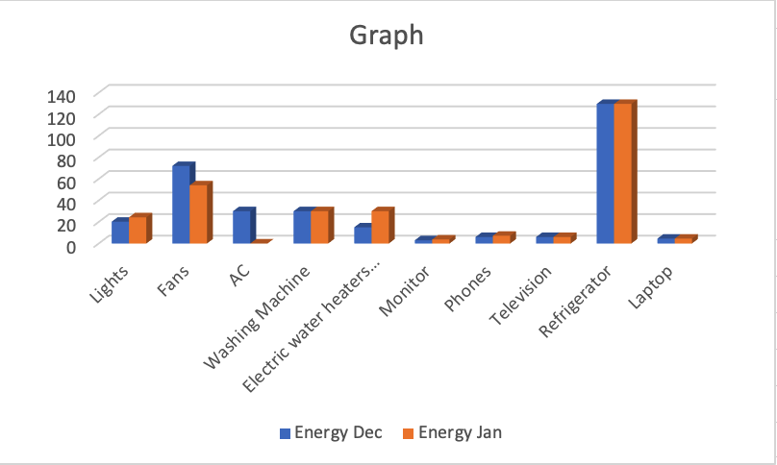

4. Compare actual electricity units and bill (Rupees) with your estimation (Use electricity bill of recent month of your home. Attach copy of the same with assignment)
Ans.
For December: -
Energy consumption | Energy units/month | Billing Rate  Rs./Unit | Total (Rs)  (without tax)
Estimated | 316.35 | 0 - 100 units: 1.75  101 - 300 units: 4.30  301 – 500 units: 7.75  Above 500 units: 8.45 | 1159.00
Actual | 314 | 0 - 100 units: 1.75  101 - 300 units: 4.30  301 – 500 units: 7.75  Above 500 units: 8.45 | 1143.50

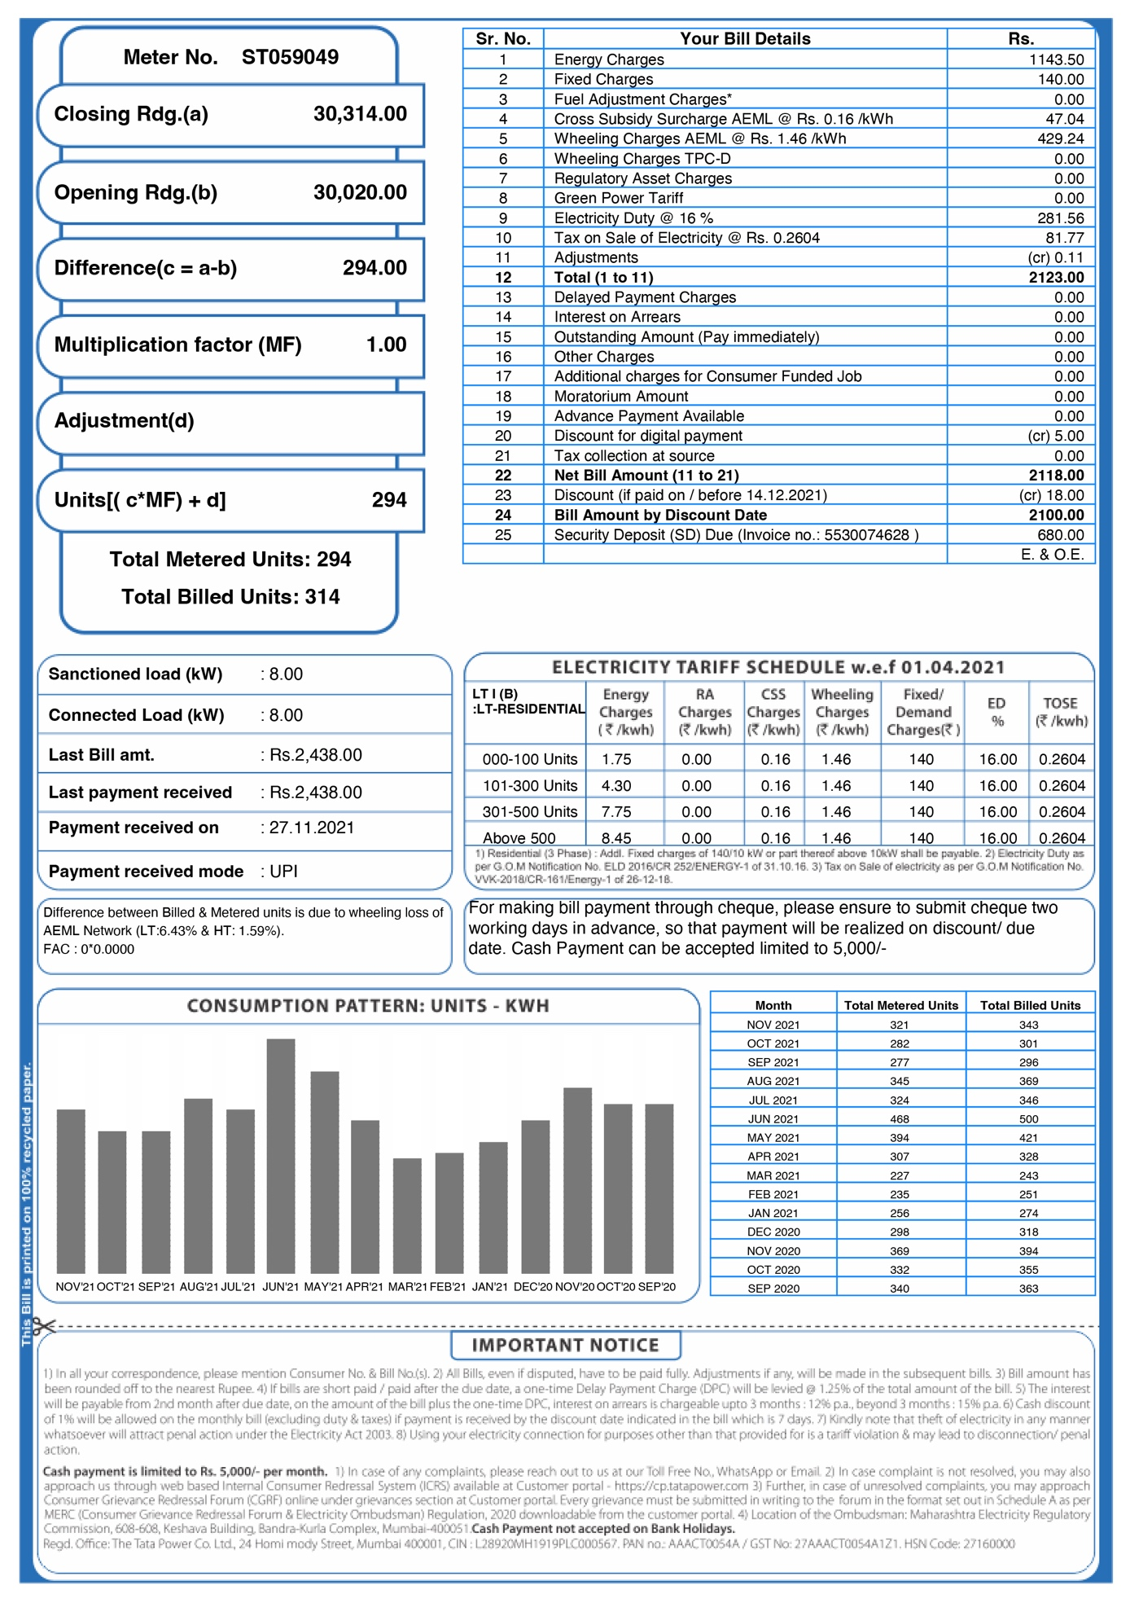
For January: -
Energy consumption | Energy units/month | Billing Rate  Rs./Unit | Total (Rs)  (without tax)
Estimated | 289.35 | 0 - 100 units: 1.75  101 - 300 units: 4.30  301 – 500 units: 7.75  Above 500 units: 8.45 | 987.7
Actual | 301 | 0 - 100 units: 1.75  101 - 300 units: 4.30  301 – 500 units: 7.75  Above 500 units: 8.45 | 1042.75
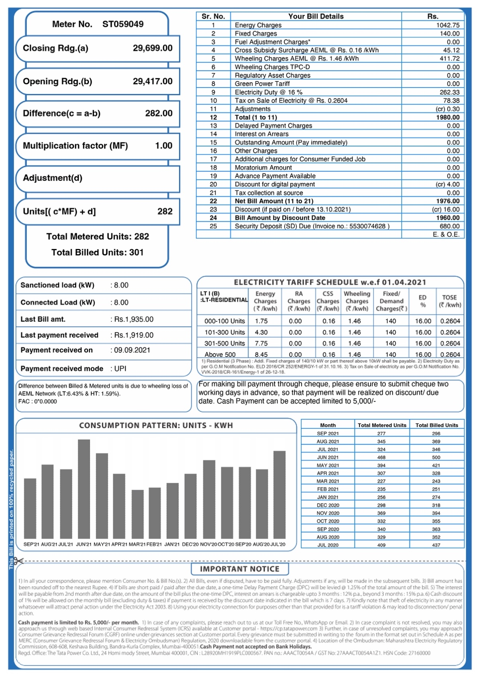

5. How you can reduce electrical energy consumption of your home? Alternative’s methods.
Ans. Here are 11 ways to start conserving energy yourself:
- Replace your light bulbs By CFL Or LED, They Use Much Less Power and Provide Better Luminosity.
- Install Automatic Light Sensors or Timed Sensors on Outdoor Lighting. Make Your Refrigerator More Efficient: Setting Your Refrigerator’s Temperature Controls to As Close To 37 Degrees to Reduce the Energy.
- Unplug Electronic Devices When Not in Use.
- Buy 5-Star Energy Rated Appliances, They Might Be Costly but Use A Lot Less Energy As Compared To Its Lower Rated Counterparts.
- Use Cold Water While Taking Showers.
- Install Energy Efficient Windows.
- Add Insulation to Hot Water Lines & The Water Heater.
- Install Solar-Powered Landscape Lighting.
- Install A Programmable Thermostat to Save Energy.
- Use Low-Flow Faucets And Showerheads.
- Install Solar panels and solar devices to utilize solar energy.

6. Estimation of electrical energy consumption after alternate methods suggested in step-5.
DECEMBER-21
Sr. No. | Appliances | Power Rating (watts/appliance) (a) | No of appliances  (b) | Utilization in Hours per day  (c) | Energy in Wh/1000 (units)/day  (d=axbxc)/1000 | Energy units/month  dx30
1 | Lights | 7  5 | 10  5 | 5  5 | 0.35  0.125 | 10.5  3.75
2 | Fans | 20 | $$4$$ | 20 | 1.6 | 48
3 | AC | 950 | 1 | 1 | 0.95 | 28.5
4 | Washing Machine | 950 | 1 | 1 | 0.95 | 28.5
5 | Electric water heaters (Geysers ) | 400 | 1 | 1 | 0.4 | 12
6 | Monitor | 25 | 1 | 4 | 0.1 | 3.0
7 | Phones | 10 | 4 | 5 | 0.2 | 6.0
8 | Television | 85 | 1 | 2 | 0.17 | 5.1
9 | Refrigerator | 150 | 1 | 24 | 3.6 | 108
10 | Laptop | 25 | 1 | 5 | 0.125 | 3.75
Total energy (Units/month) |  |  |  |  |  | 257.1

JANUARY-2022
Sr. No. | Appliances | Power Rating (watts/appliance) (a) | No of appliances  (b) | Utilization in Hours per day  (c) | Energy in Wh/1000 (units)/day  (d=axbxc)/1000 | Energy units/month  dx30
1 | Lights | 7  5 | 10  5 | 6  6 | 0.42  0.15 | 12.6  4.5
2 | Fans | 20 | $$4$$ | 15 | 1.2 | 36
3 | AC | 950 | 1 | 0 | 0 | 0
4 | Washing Machine | 950 | 1 | 1 | 0.95 | 28.5
5 | Electric water heaters (Geysers ) | 400 | 1 | 2 | 0.8 | 24
6 | Monitor | 25 | 1 | 5 | 0.125 | 3.75
7 | Phones | 10 | 4 | 6 | 0.24 | 7.2
8 | Television | 85 | 1 | 2 | 0.17 | 5.1
9 | Refrigerator | 150 | 1 | 24 | 3.6 | 108
10 | Laptop | 25 | 1 | 5 | 0.125 | 3.75
Total energy (Units/month) |  |  |  |  |  | 233.4

Plot the bar graph showing the comparison of consumption of December-2021 & January-2022 with alternate methods suggested
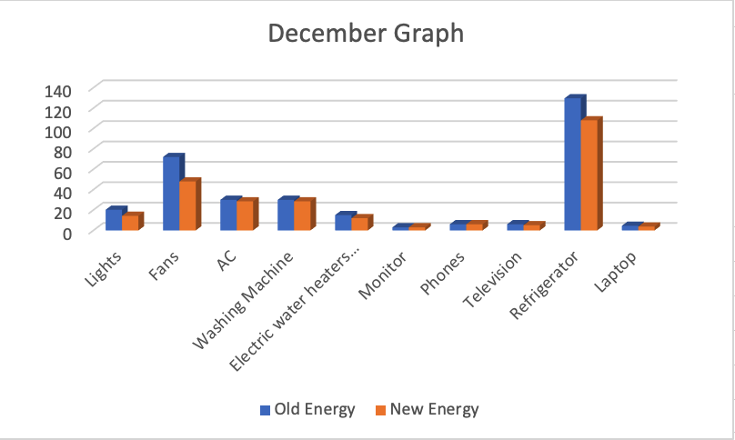

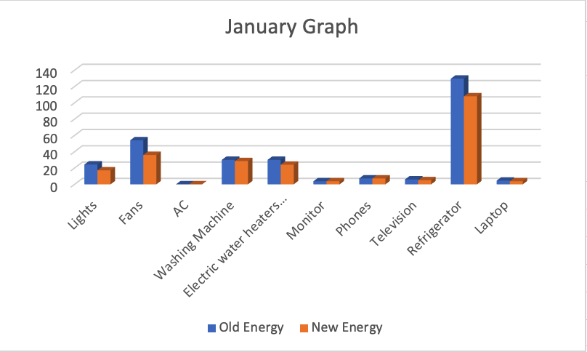

7. Energy saving units/month and expenses in Rs/month (after implementation of alternative method suggested in steps 5 & 6)
Ans.
For December: -
Energy consumption | Energy  units/month | Total (Rs)
Estimated | 316.35 | 1159
Alternate | 257.1 | 850.10
Actual | 314 | 1143.5

Energy Saved Per Month: 314 – 257.1 = 56.9 Units
INR Saved: 1143.5 – 1159 = Rs 291.4

For January: -

Energy consumption | Energy  units/month | Total (Rs)
Estimated | 289.35 | 987.70
Alternate | 233.4 | 746.90
Actual | 301 | 1042.75

Energy Saved Per Month: 301 – 233.4 = 11.65 Units
INR Saved: 1042.75 – 746.90 = Rs 295.85

Signature of faculty in-charge with Date:

